These workshops are run by Christine Pike, MA, a professional sculptor of many years’ standing, whose work includes public and private commissions, and can be seen in galleries throughout the UK.
Christine takes her inspiration from the natural world and from folklore. Her work tells stories about what it is to be human, although sometimes her figures disguise themselves as animals. Occasionally they are caught in the act of transformation, halfway between human and beast…

26 September 10 am - 4 pm FULL
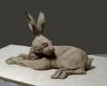
One Day - Hare Sculpture Workshop (beginners/intermediate) - £155

In this one-day workshop you will be introduced to various hand-building techniques, which should enable you to complete a small reclining hare sculpture by the end of the day.

Suitable for anyone who has some experience of working with clay (even if it was many years ago, at school or college!).

12 December 10 am - 1 pm Morning: FULL

Half Day Workshop - Animal Heads (beginners/intermediate) - £95

So many sculptures start with a thumb/pinch pot! In this fun workshop you will learn how to turn a basic thumb pot into different furred and feathered animal head
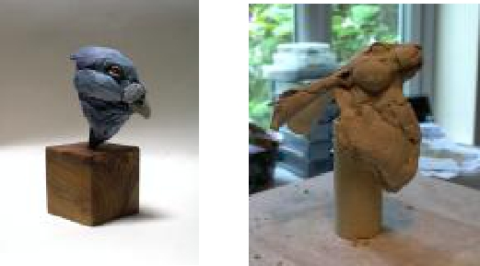
studies. You will also be given tips on how to colour and present your finished pieces.

This workshop is a useful introduction for anyone who has always wanted to try their hand at clay sculpting but never given it a go.
12 December 2 pm - 5 pm Afternoon

Half Day Workshop - Animal Heads (beginners/intermediate) - £95

19 December 10 am - 4 pm
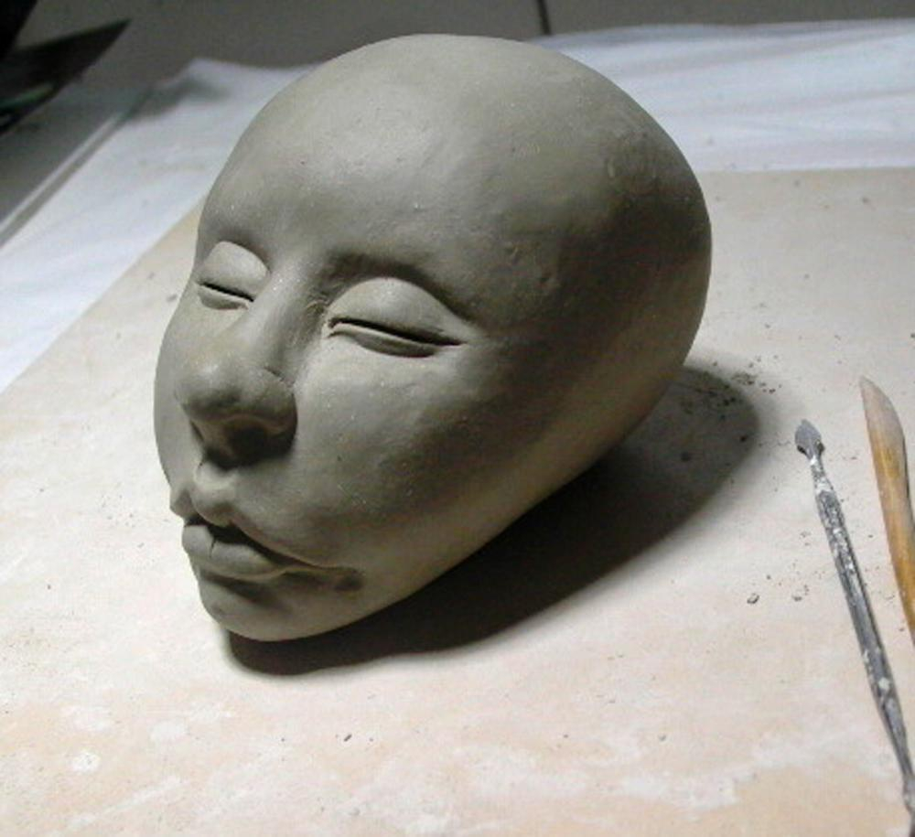
One Day - Human Head Workshop* (intermediate/advanced) - £155
In this one-day workshop you will be shown how to create a medium to life-
sized head which you can make into a contemporary sculpture or even,
(once you have hollowed it out), into a beautiful planter or lidded container.

Please note: this is not a life sculpting class - instead you will be shown how to
create a head from your imagination. If you have never sculpted a head before
we suggest you consider one of the shorter workshops first.

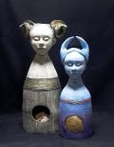
9 - 10 January 2022 10 am - 4 pm

Two Day - Fantastic Figures Workshop (advanced) - £300

Be encouraged to see with your inner eye and create a contemporary figure inspired by your imagination, using different clay hand-building techniques.

Some sculpting experience preferred, but more important is a willingness to let
the clay take you on a journey of discovery to make a sculpture that has
personal significance to you. In this two-day workshop you will be introduced to many different techniques to help you create a sculpture out of your own imagination.

Please prepare by thinking about what you would like to create, and bring along
with you any material that inspires you - it could be a picture, a photograph, a small object, or a piece of text or poem.

This course is suitable for intermediate and advanced students.

Included in the course is:

One or more pieces of work completed in the session fired to bisque; additional pieces can be fired at a small additional cost. A 12.5kg bag of clay which will be used to create your work, the remainder for you to take home to practice your new found skills.

All tools will be supplied but we ask that you bring your own apron.

Workshops / Courses held at:

Fire and Flux Ceramics
21 Lower Goat Lane, Norwich NR21EL

T:01603322796. E:fireandfluxceramics@gmail.com. w: www.fireandfluxceramics.co.uk

Please be aware of our cancellation policy which can be found on our website.

